Result Management System

GROUP MEMBERS

***SHASHANK GUPTA***

***SUNIL KUMAR MEENA***

***POOJA GUPTA***

***AJAY***

***BIBEK KR. KUSHWAHA***

## PROBLEM STATEMENT

In our project "Students Result Management" we will register all the

details of the students of a particular course. Likewise it will take the

number of courses as input. Accordingly we have to update the marks

of the subjects of a student. After taking all the requirements as

input, In our project it will generate the student profile. In that profile

it will show the students detail, his/her marks and basis of given

criteria it will generate the grade also. We can see the course wise

students marks and it's statistics respectively.

**SOFTWARE** **REQUIREMENT** **SPECIFICATION**

**1.** **INTRODUCTION**

**1.1** **Project** **Purpose**

This project is aimed to facilitate the students to view their academic grades and

statistics for their registered courses in a semester. The marks are evaluated and

maintained by the allotted teachers for the subjects. This provide the facility

to view the result anytime and anywhere. The main purpose of this system is to

provide an efficient way for maintaining the academic records of the students

by the teachers.

**1.2** **Product** **Scope**

* Stores the student details in the Database.
* Makes one supervisor from teachers for each student.
* Allows student and teacher to login successfully.
* Allows Supervisor to view marks and other details of all the enrolled students.
* Allows the teacher to modify(add/ update) the marks of the students for their

respective subjects. On the basis of these marks and other criteria, the Grades

will be evaluated.

* Allows the teacher to add or delete student record from the Database.
* Allows the student to view their marks, grades and other statistics.
* Allows to view course-wise statistics to supervisor, teacher and student.
* To add or delete subjects.

**1.3** **Deﬁnitions** **and** **Acronyms**

* **User(Student) :** A registered individual who visits the this system to view the

marks, grades and other statistics.

* **Admin(Teacher) :** A registered individual who manages the application. An

admin can add/delete subjects and maintains the marks record of the students

for their respective subject.

**1.4** **References** **and** **Acknowledgements**

* Evaluation of Grade at SCSS Department, JNU, New Delhi- 110067.

**2.** **OVERALL** **DESCRIPTION**

**2.1** **Product** **Description**

The product is intended to be an improvement on a traditional way of evaluating

marks and grades. Therefore, some features like storing the details of the student

will be common to existing software, others will be unique. Speed and compatibility

are two of the intended areas to be improved allowing the application to run on

computers with small amounts of memory.

**2.2** **Product** **Functionalities**

**2.2.1** **Administrator/Admin(Teacher)** **module**

* This section can be accessed by providing administrator username and password
* In this section, the administrator can save the information related to marks for the

exams( Minor, Mid, or End-Sem Exams) so that Grades can be evaluated.

* The administrator can modify the information related to marks of the exams

held for their respective subject.

* The administrator can also edit the information related to student details.

**2.2.2** **Official Supervisor** **module**

Official Supervisor is that teacher who can have multiple supervisee (student) under

him/her. Supervisors can guide their supervisee whenever needed.

* Official Supervisor can view marks, grades for any student for all subjects.
* Official Supervisor can add/delete subjects to the students.
* Official Supervisor can add/delete students as their supervisee.

**2.2.3** **User(Student)** **module**

* User can view marks, grade and other statistics for his/her registered subjects for

the semester.

* User can also view his/her details stored in the Database.

**2.3** **Characteristics of the Users (Teacher, Student)**

Users of the system are distinguishable in three categories:

* Student as a Member: The enrolled students in the course of the institution and further having registered for the subjects.
* Supervisor as a Member : The teachers are the supervisors to the students who

can guide their supervisee( students). Each supervisor can have multiple students

under them as supervisee.

* Teacher as a Member : Teacher refers to the subject teacher who is allotted to teach a particular course. Teacher maintains the record of the marks and grades of the

students for their respective subject and hence, manages the system.

* Members and Managers are assumed to have basic knowledge of computers.
* User friendly interface is sufﬁcient to educate the users in how to use the system without problems or difficulties.

**2.4** **Design** **and** **Implementation** **constraints**

* The product is designed and implemented in C language.
* System is platform dependent.
* The information of all the users, students and teachers must be stored

in a database that is accessible by the system and the admin.

* Text ﬁles linked with the C program will be used as database.
* Student Record Management System is running 24 hours a day.
* Users must have their correct usernames and subject codes to enter into their

accounts and perform further actions.

**2.5** **Assumptions** **and** **Dependencies**

The product is platform dependent and can be run on only one device. When

using the product it will be assumed that user have some knowledge about

computers.

**3.** **SPECIFIC** **REQUIREMENTS**

**3.1** **External** **Interface** **Requirements**

**3.1.1** **Hardware** **Requirements:**

* A Computer with Intel Pentium and Celeron class processor.
* **Speed :** 1.1 GHz.
* **RAM :** 512MB
* **Hard Disk :** 4GB space.
* **Mouse :** Normal
* **Keyboard :** Normal.

**3.1.2** **Software** **Requirements:**

* **Operating System :** Windows XP/7/8/10.
* **Database :** text ﬁles and C language.
* **Frontend :** C language.
* **Backend :** C language.

**3.2** **Functional** **Requirements** **:**

|  |  |  |
| --- | --- | --- |
| **Functional** **Requirement** | **Product** **Function** | **Description** |
| **FR1** | User Registration | User registered with first name, last name, contact number, username and subject codes. |
| **FR2** | User Login | User can login with username and subject code. |
| **FR3** | Admin Login | Admin can login with admin username and password. |
| **FR4** | Marks Evaluation | Admin can create exams, modify marks for the same after login into the system with username and password. • Then student can view the marks and calculated grade. |
| **FR5** | Search Evaluated Marks | User and Supervisor both can search the result(marks evaluated) to check the grade for the subject after login. |
| **FR6** | Add Student | Supervisor can add student under his/her supervision.  Admin can create student record from the system. |
| **FR7** | Delete Student | Supervisor can delete student as their supervisee from the database.  Admin can delete the student record from the system. |
| **FR8** | Modify Marks | Admin can modify the marks for the students for their respective subject. |
| **FR9** | Show Marks (Result) | Admin, Supervisor and Student  can login into the system.Then, they  can view the Grade and other  statistics available at that time. |

**4.** **Non** **Functional** **Requirements**

**4.1** **Security**

* The system’s database shall only be accessible to authenticated

administrators.

* Sensitive data will be encrypted before being recorded.

**4.2** **Reliability**

* The reliability of the overall program depends on the reliability of separate

components.

* The main pillar of the reliability of the system is the database which

is continuously maintained and updated to reﬂect the most recent changes.

* Thus the overall stability of the system depends on its underlying

operating system.

**4.3.** **Availability**

* The system should be available at all the times, meaning the user can access

it anytime.

* In case of hardware failure or database corruption, backups of the database

should be retrieved and saved by the administrator.

**4.4** **Maintainability**

* In case of failure, a re-initialization of the program shall be done.
* Also the product design is being done with modularity in mind so the

maintainability can be done efficiently.

## DESIGN DOCUMENT

## 1.DATA FLOW DIAGRAM:

A Data Flow Diagram (DFD) is a traditional way to visualize the information flows within a system. A neat and clear DFD can depict a good amount of the system requirements graphically. It can be manual, automated, or a combination of both.

It shows how information enters and leaves the system, what changes the information and where information is stored. The purpose of a DFD is to show the scope and boundaries of a system as a whole. It may be used as a communications tool between a systems analyst and any person who plays a part in the system that acts as the starting point for redesigning a system.

The symbols used in a DFD are as follows:

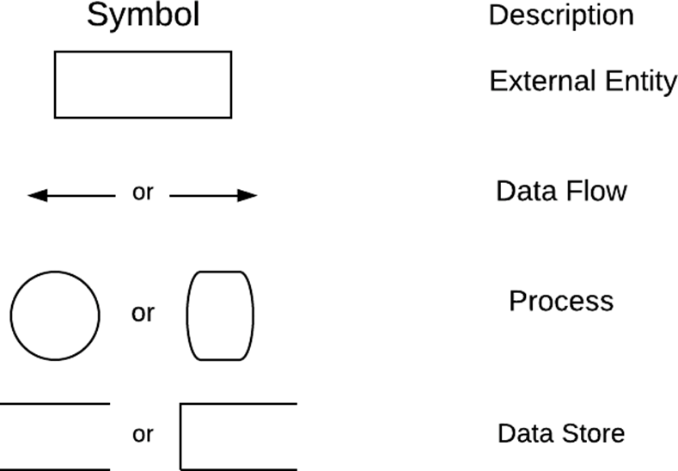

**Level-0 DFD**

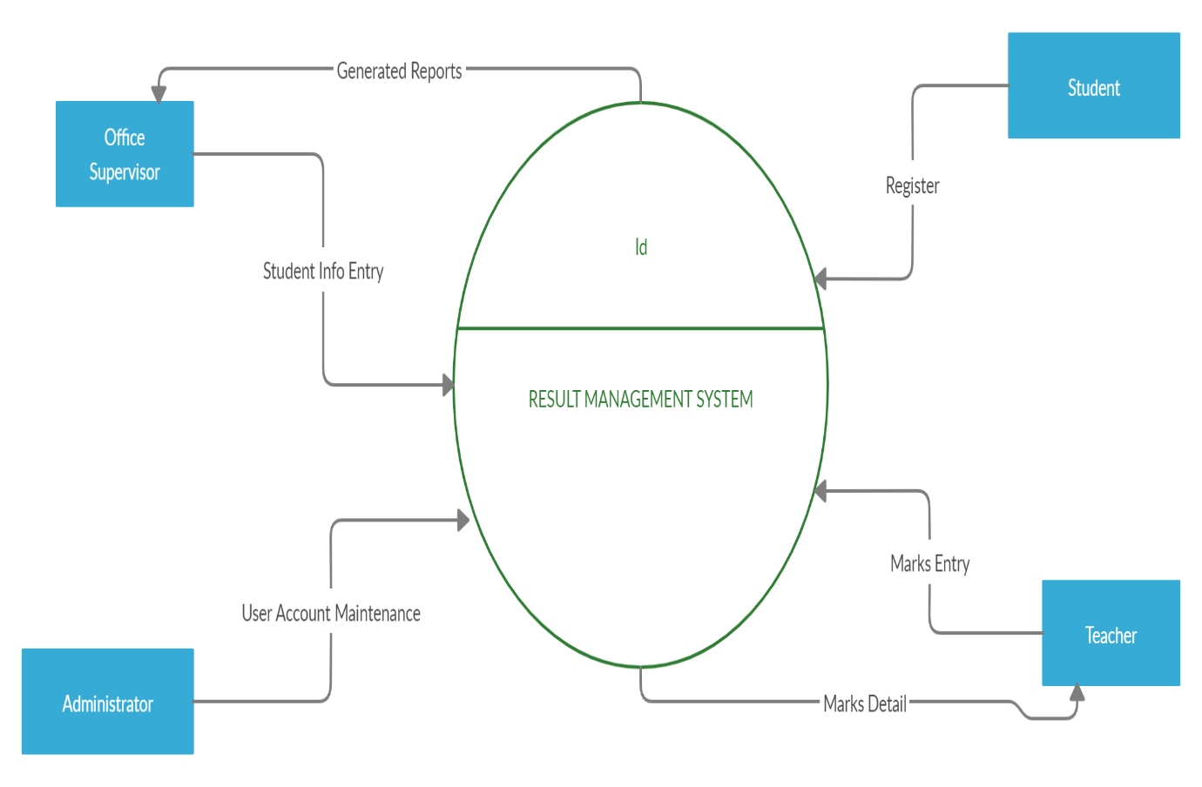

**Level-1 DFD**

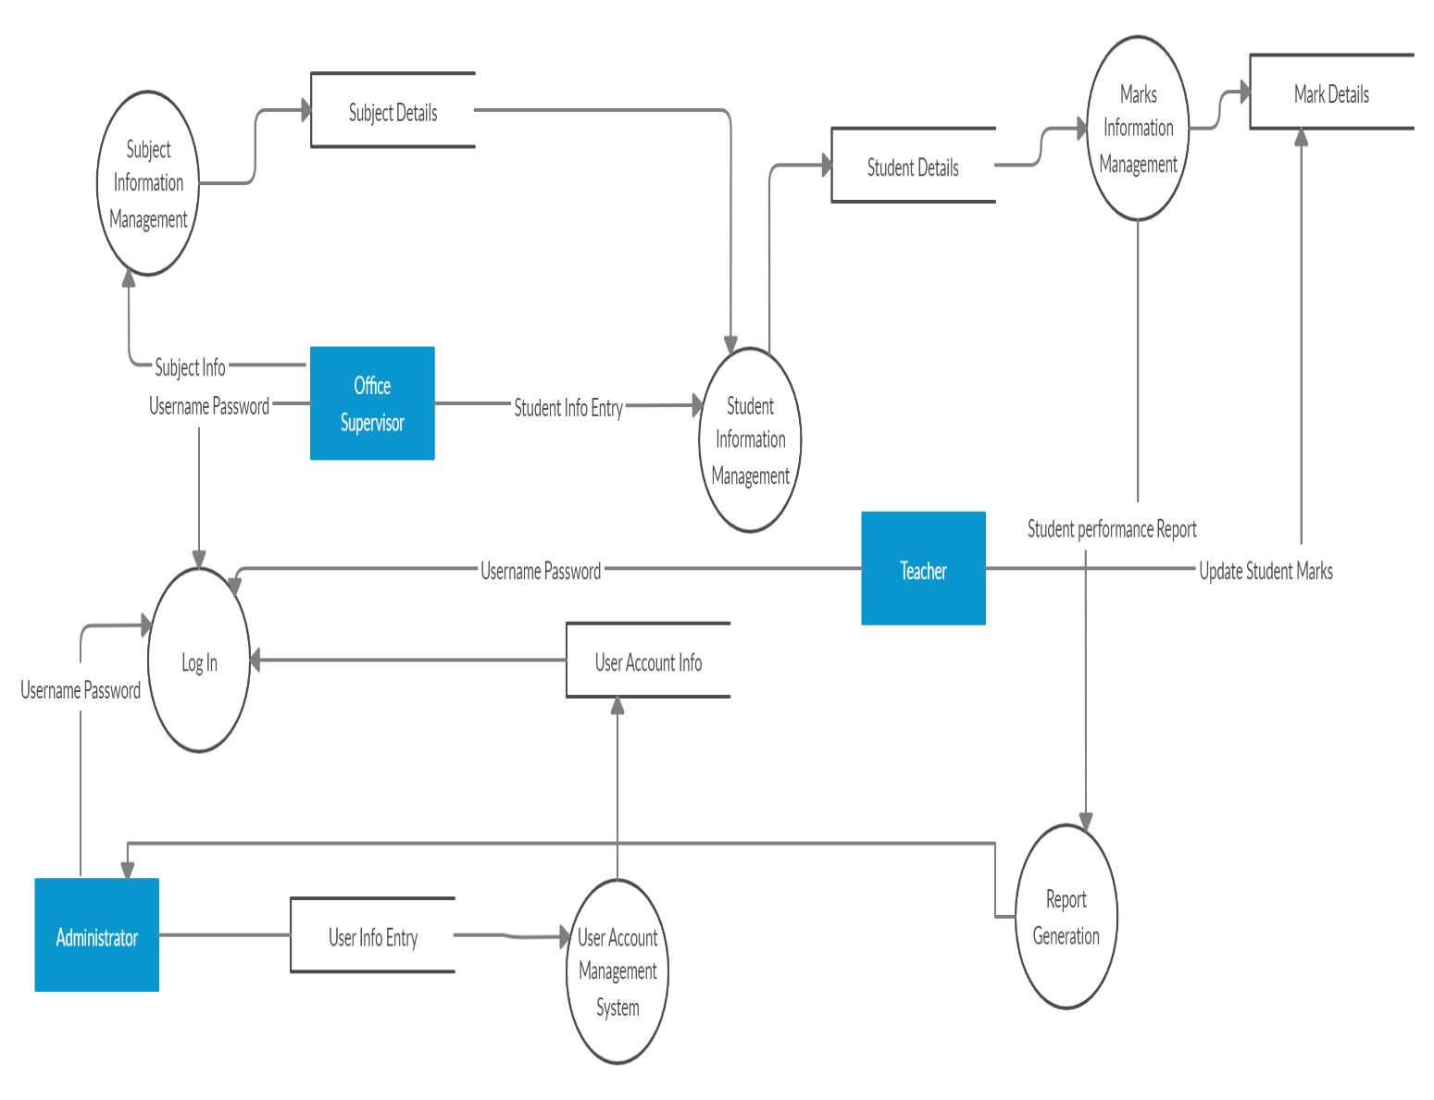

**Level-2 DFD of Login**

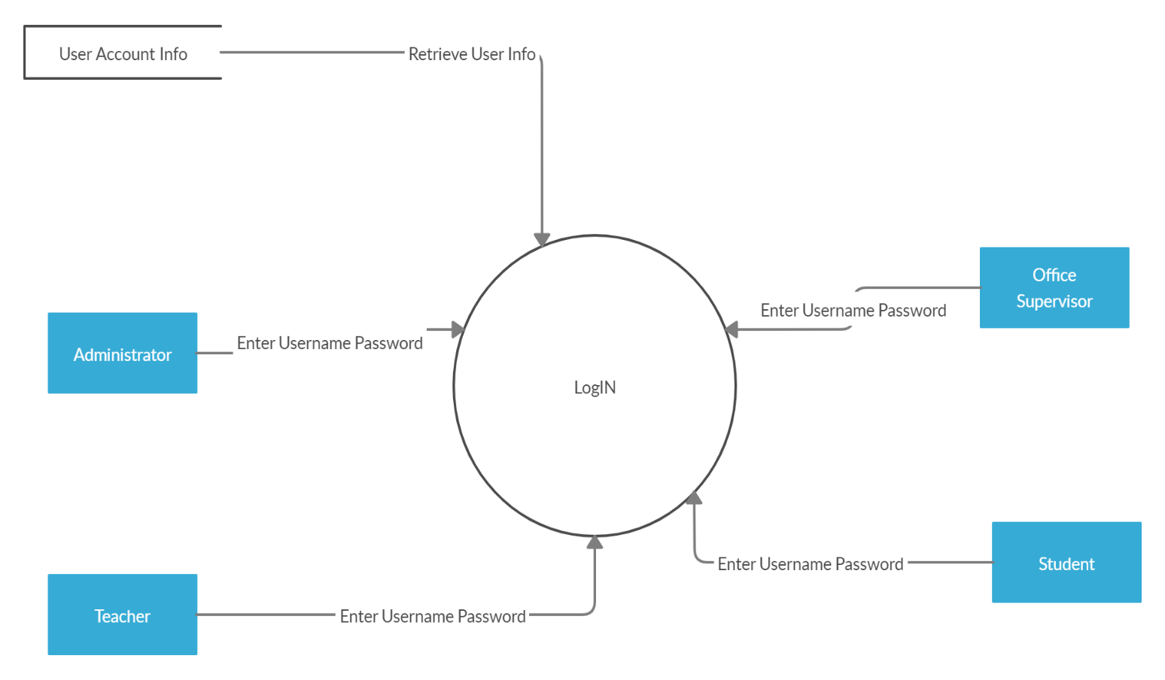

**Level-2 DFD of User Account Maintenance**

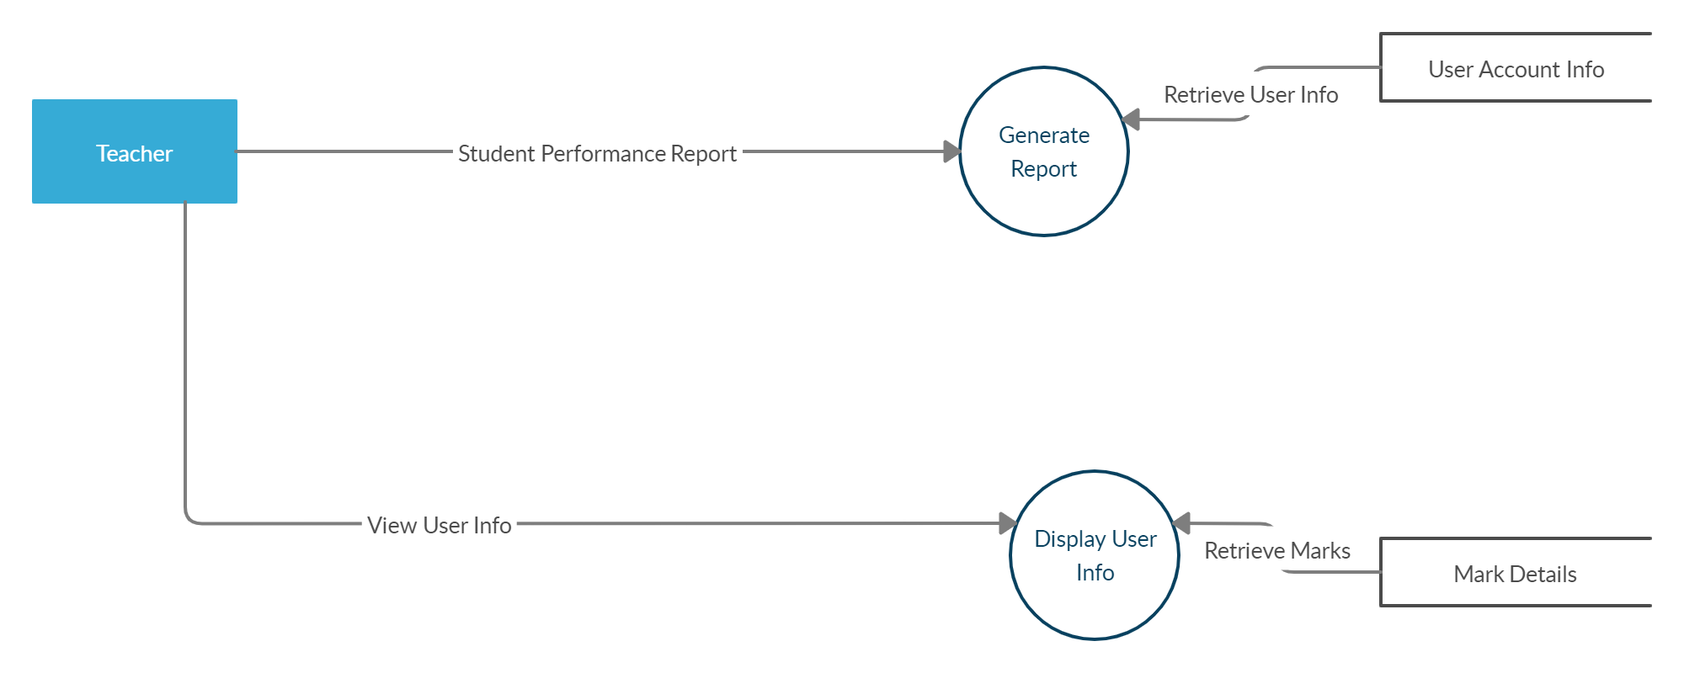

**Level-2 DFD of Student Information Management**

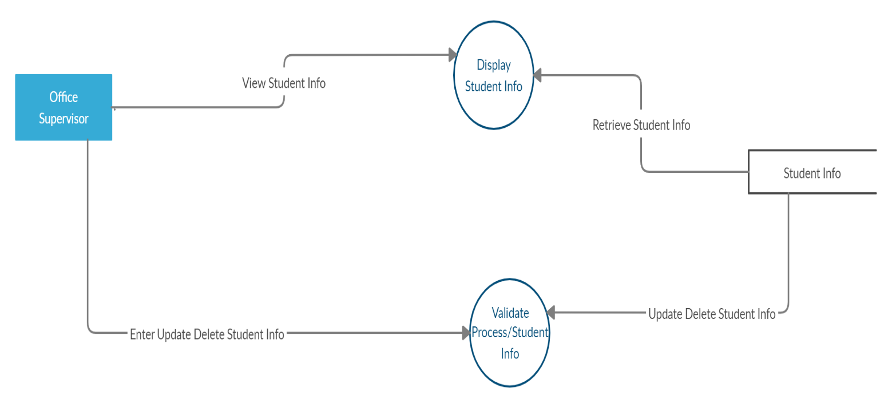

**Level-2 DFD of Subject Information Management**

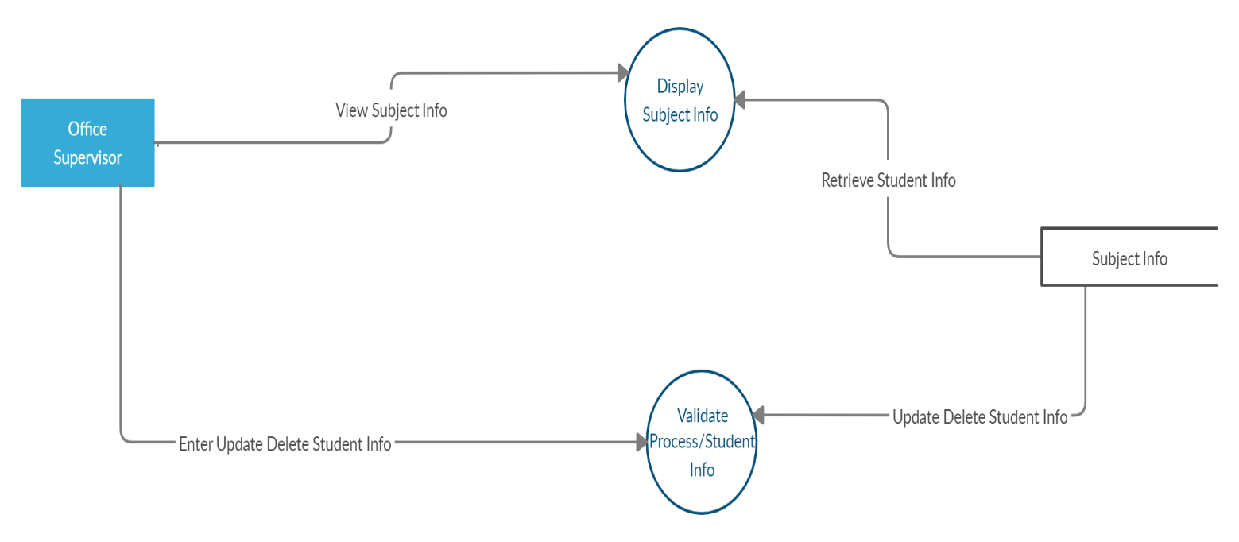

**Level-2 DFD of Marks information management**

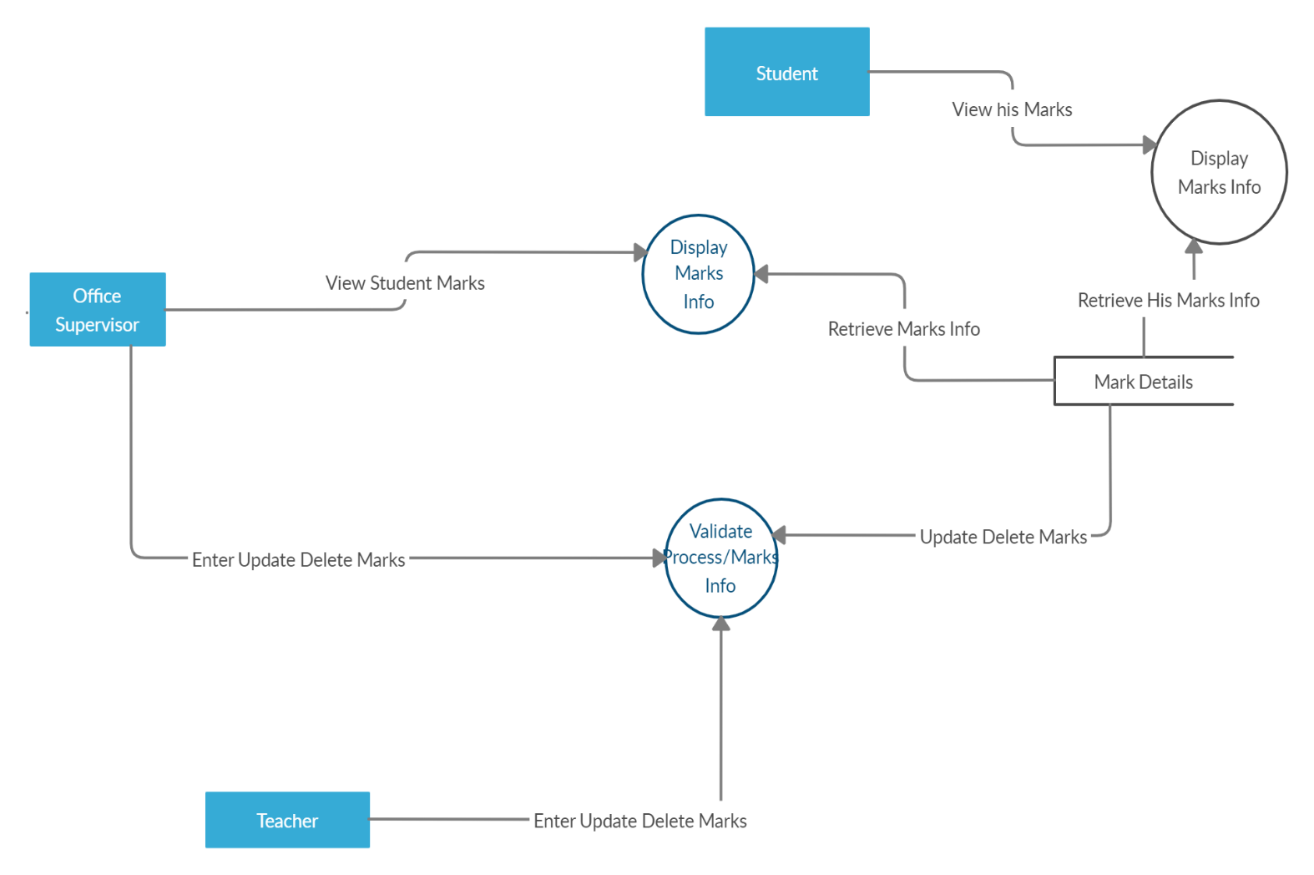

**2. PROCESS SPECIFICATION**

It defines what must be done in order to transform the inputs to outputs. A process must be expressed in a form that can be verified by the user and the system’s analyst. It should also be designed such that it can be effectively communicated to the various audiences involved.

## 

## 2.1 Using Structured English

It is basically English with structure. It’s purpose is to strike a reasonable balance between the precision of a formal programming language and the casual informality and readability of the English language.

**Process Specification:-**

**1.OS**

1. Create student's profile

OPEN CreateStudentProfile()

OPEN Student file in append mode.

INPUT name, dob, enroll, Program name, mobile no, email, password.

WRITE into file if enroll is not exist.

END CreateStudentProfile().

2. Display Student profile()

OPEN showAllStudents()

PRINT student's name, dob, enroll, Program name, mobile no, email, password.

PRINT student's obtained marks.

END showAllStudents()

3. Add new course

OPEN createCourse()

OPEN course file in append mode.

INPUT course code, course name, course description, course password.

WRITE into file if enroll is not exist.

END CreateStudentProfile().

4. Delete all students profile

OPEN DeleteAllStudentsRecord()

OPEN student.dat file in writing mode.

END DeleteAllStudentsRecord()

5. See Available course

OPEN showCourse()

OPEN course.dat file in read mode.

LOOP UNTILL course ends in file

PRINT course code, course name, course description.

ENDLOOP

END showCourse()

6. Delete all course

OPEN DeleteAllCourses()

OPEN new course2.dat file in writing mode.

OPEN new course.dat file in writing mode.

REMOVE course.dat file.

RENAME course2.dat file to course.dat file

END DeleteAllCourses()

7. See course wise statistics

**2. TEACHER**

1. Add Marks

OPEN AddingMarks()

OPEN students.dat file in writing mode.

OPEN students2.dat file in writing mode.

INPUT which exam marks teacher is going to add.

LOOP read all student form students.dat one by one.

INPUT student's marks respectively.

WRITE student's marks in student2.dat file.

ENDLOOP

REMOVE students.dat file.

RENAME student2.dat file to student.dat

END AddingMarks()

2. Update marks

OPEN UpdateMarks()

OPEN students.dat file in writing mode.

OPEN students2.dat file in writing mode.

INPUT which exam marks teacher is going to add.

INPUT which student's marks teacher is going to update.

LOOP read all student form students.dat one by one.

IF student is found as givent enrollment number

INPUT student's marks respectively.

ENDIF

WRITE student's marks in student2.dat file.

ENDLOOP

REMOVE students.dat file.

RENAME student2.dat file to student.dat

END UpdateMarks()

3. Coursewise statistics

**3. STUDENT**

1. See student profile

OPEN showSigleStudentByStudent()

OPEN student.dat file in read mode.

INPUT student's enrollment number

CHECK IF student's enrollment number is exist.

ENDIF

INPUT student's password.

CHECK IF student's password is correct.

PRINT student's name, dob, enroll, Program name, mobile no, email, password.

PRINT student's obtained marks.

ENDIF

END showSigleStudentByStudent()

**4. ADMIN**

**1. Create login profile**

OPEN create login profile().

OPEN loginfile.dat file in write mode.

INPUT whom profle credential you are going to enter ex: teacher.

INPUT username and password.

WRITE it into loginfile.dat file.

CLOSE loginfile.dat file.

END

**2. Login function**

OPEN loginfunction()

OPEN loginfile.dat file in read mode.

INPUT whom profle credential you are going to enter ex: teacher.

INPUT username and password.

Check whether username and password are correct.

RETURN TRUE if credential are true else false;

END

## 2.2. PRE AND POST CONDITIONS

It is a convenient way to describe the function without considering the algorithm and procedure to be used.

There are two main parts: PRE-Condition and POST Condition.

### **PRE-CONDITION:**

1. Describes what must be true before the process begins operating.
2. It describes what input must be available.
3. It describes what relationship must exist among inputs.
4. It describes relationship between inputs and data stores.

### **POST CONDITION:**

1. Describes what must be true when a process has finished operating.
2. It describes the output that must be generated by the process.
3. It describes the relationships that must exist between the output values and the original input values.
4. It describes output values in one or more stores.
5. It describes changes made to the stores.

We shall use Pre/Post conditions for process specification of each process described in the Data Flow Diagram.

### The Pre/Post conditions for the processes are detailed below:

**PRE AND POST CONDITIONS**

It is a convenient way to describe the function without considering the algorithm

and procedure to be used.

There are two main parts: PRE-Condition and POST Condition.

**PRE-CONDITION:**

* a) Describes what must be true before the process begins operating.
* b) It describes what input must be available.
* c) It describes what relationship must exist among inputs.
* d) It describes relationship between inputs and data stores.

**POST CONDITION:**

* a) Describes what must be true when a process has finished operating.
* b) It describes the output that must be generated by the process.
* c) It describes the relationships that must exist between the output values and

the original input values.

* d) It describes output values in one or more stores.
* e) It describes changes made to the stores.

**1.OS**

**1. Create student's profile()**

Pre - condition:- Open students.dat file and the enter name, dob, enroll, Program

name, mobile no, email, password.

Post - condition:- Write into student.dat file after taking name, dob, enroll,

Program name, mobile no, email,password as input.

**2. Display Student profile()**

Pre - condition:- Open students.dat file.

Post - condition:- Display name, dob, enroll, Program name, mobile no, email,

password on screen.

**3. Add new course()**

Pre - condition:- Open course.dat file in writing mode and then enter course code,

course name, course description, course password.

Post - condition:- write into course.dat file after taking course code, course name,

course description, course password as input.

**4. Delete all students profile()**

Pre - condition:- Open students.dat file in writing mode.

Post - condition:- Close student.dat file without write anything.

**5. See Available course()**

Pre - condition:- Open course.dat file in reading mode.

Post - condition:- Print all available course on course.dat file using loop.

**6. Delete all course**

Pre - condition:- Open course.dat in writing mode and a new file course2.dat in

writing mode.

Post - condition:- Now rename course2.dat as course.dat file.

**7. See course wise statistics**

**2. TEACHER**

**1. Add Marks**

Pre - condition:- Open students.dat and students2.dat in writing mode. Input which

exam marks that teacher is going to add. Using loop read every student's record

one by one from students.dat and add marks and write back to students2.dat file.

Post - condition:- Rename student2.dat file to student.dat

**2. Update marks**

Pre - condition:- Open students.dat and students2.dat in writing mode. Input

which exam marks that teacher is going to add and which student's marks teacher

is going to add. Using loop read entered student's record from students.dat and

add marks and write back to students2.dat file.

Post - condition:- Rename student2.dat file to student.dat

**3. Coursewise statistics**

**3. STUDENT**

**1. See student profile**

Pre - condition:- Open students.dat file in read mode. Input student's

enrollment number and check whether it is valid or not. Read entered

enrollment's student and take password as input and authenticate.

Post - condition:- Print student's name, dob, enroll, Program name, mobile no,

email, password. Print student's obtained marks.

**4. ADMIN**

**1. Create login profile**

Pre - condition:- Open loginfile.dat file in writing mode. Input whom profle credential you are going to enter ex: teacher. Take username and password as input.

Post - condition:- If inputs is success then write this to loginfile.dat file.

**2. Login function**

Pre - condition:- Open loginfile.dat file in reading mode. Input whom profle credential you are going to enter ex: teacher. Take username and password as input.

Post - condition:- Return TRUE if given input is found in out login.dat file else return FALSE.

## DATA DICTIONARY

A data dictionary contains metadata i.e data about the database. The data dictionary is very important as it contains information such as what is in the database, who is allowed to access it, where is the database physically stored etc. The users of the database normally don't interact with the data dictionary, it is only handled by the database administrators.

The data dictionary in general contains information about the following

* + Names of all the database tables and their schemas.
  + Details about all the tables in the database, such as their owners, their security constraints, when they were created etc.
  + Physical information about the tables such as where they are stored and how.
  + Table constraints such as primary key attributes, foreign key information etc.
  + Information about the database views that are visible.

The conventions used are listed below:

a) * * comments

b)[ ] one of the several choices

c)@ key field of a store

d) | choice

e)= composed of

f)+ and

g) ( ) optional

h) n{ }m at least n, at most m

i) 0{ }m zero or more, at most m

j) n{ } at least n, no limit

Data Dictionary for our system will be as:

USER ACCOUNT INFORMATION = [USERNAME + PASSWORD]

MARK DETAILS= [MINOR + MID + END SEMESTER]

STUDENT DETAILS= [NAME + ENROLLMENT NO. + DATE OF BIRTH + PROGRAMME NAME + MOBILE NO. + EMAIL + COURSE]

SUBJECT DETAILS= [COURSE NAME + COURSE CODE + COURSE DESCRIPTION]

DATE OF BIRTH= [ YEAR + MONTH + DAY]

NAME=[FIRSTNAME + LASTNAME]

**STRUCTURE CHARTS**

Structure Chart represent hierarchical structure of modules. It breaks down the entire system into lowest functional modules, describe functions and sub-functions of each module of a system to a greater detail. Structure Chart partitions the system into black boxes (functionality of the system is known to the users but inner details are unknown). Inputs are given to the black boxes and appropriate outputs are generated.

Modules at top level called modules at low level. Components are read from top to bottom and left to right. When a module calls another, it views the called module as black box, passing required parameters and receiving results.

**ADMIN**

**Factor Afferent :**

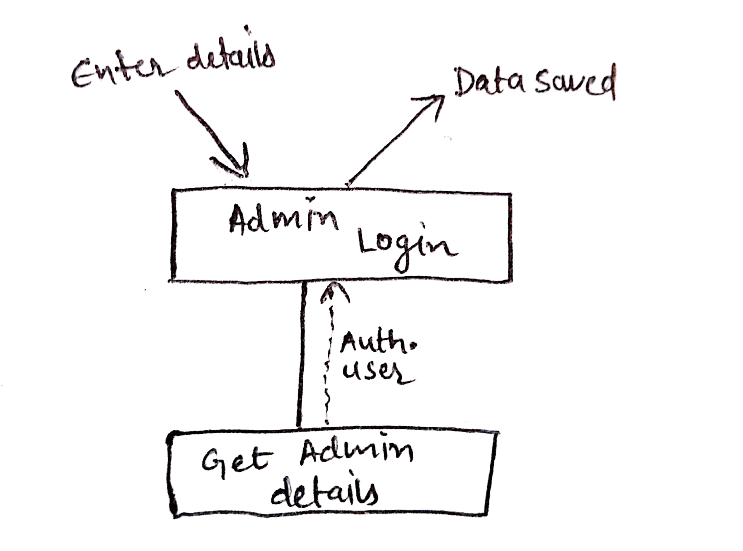

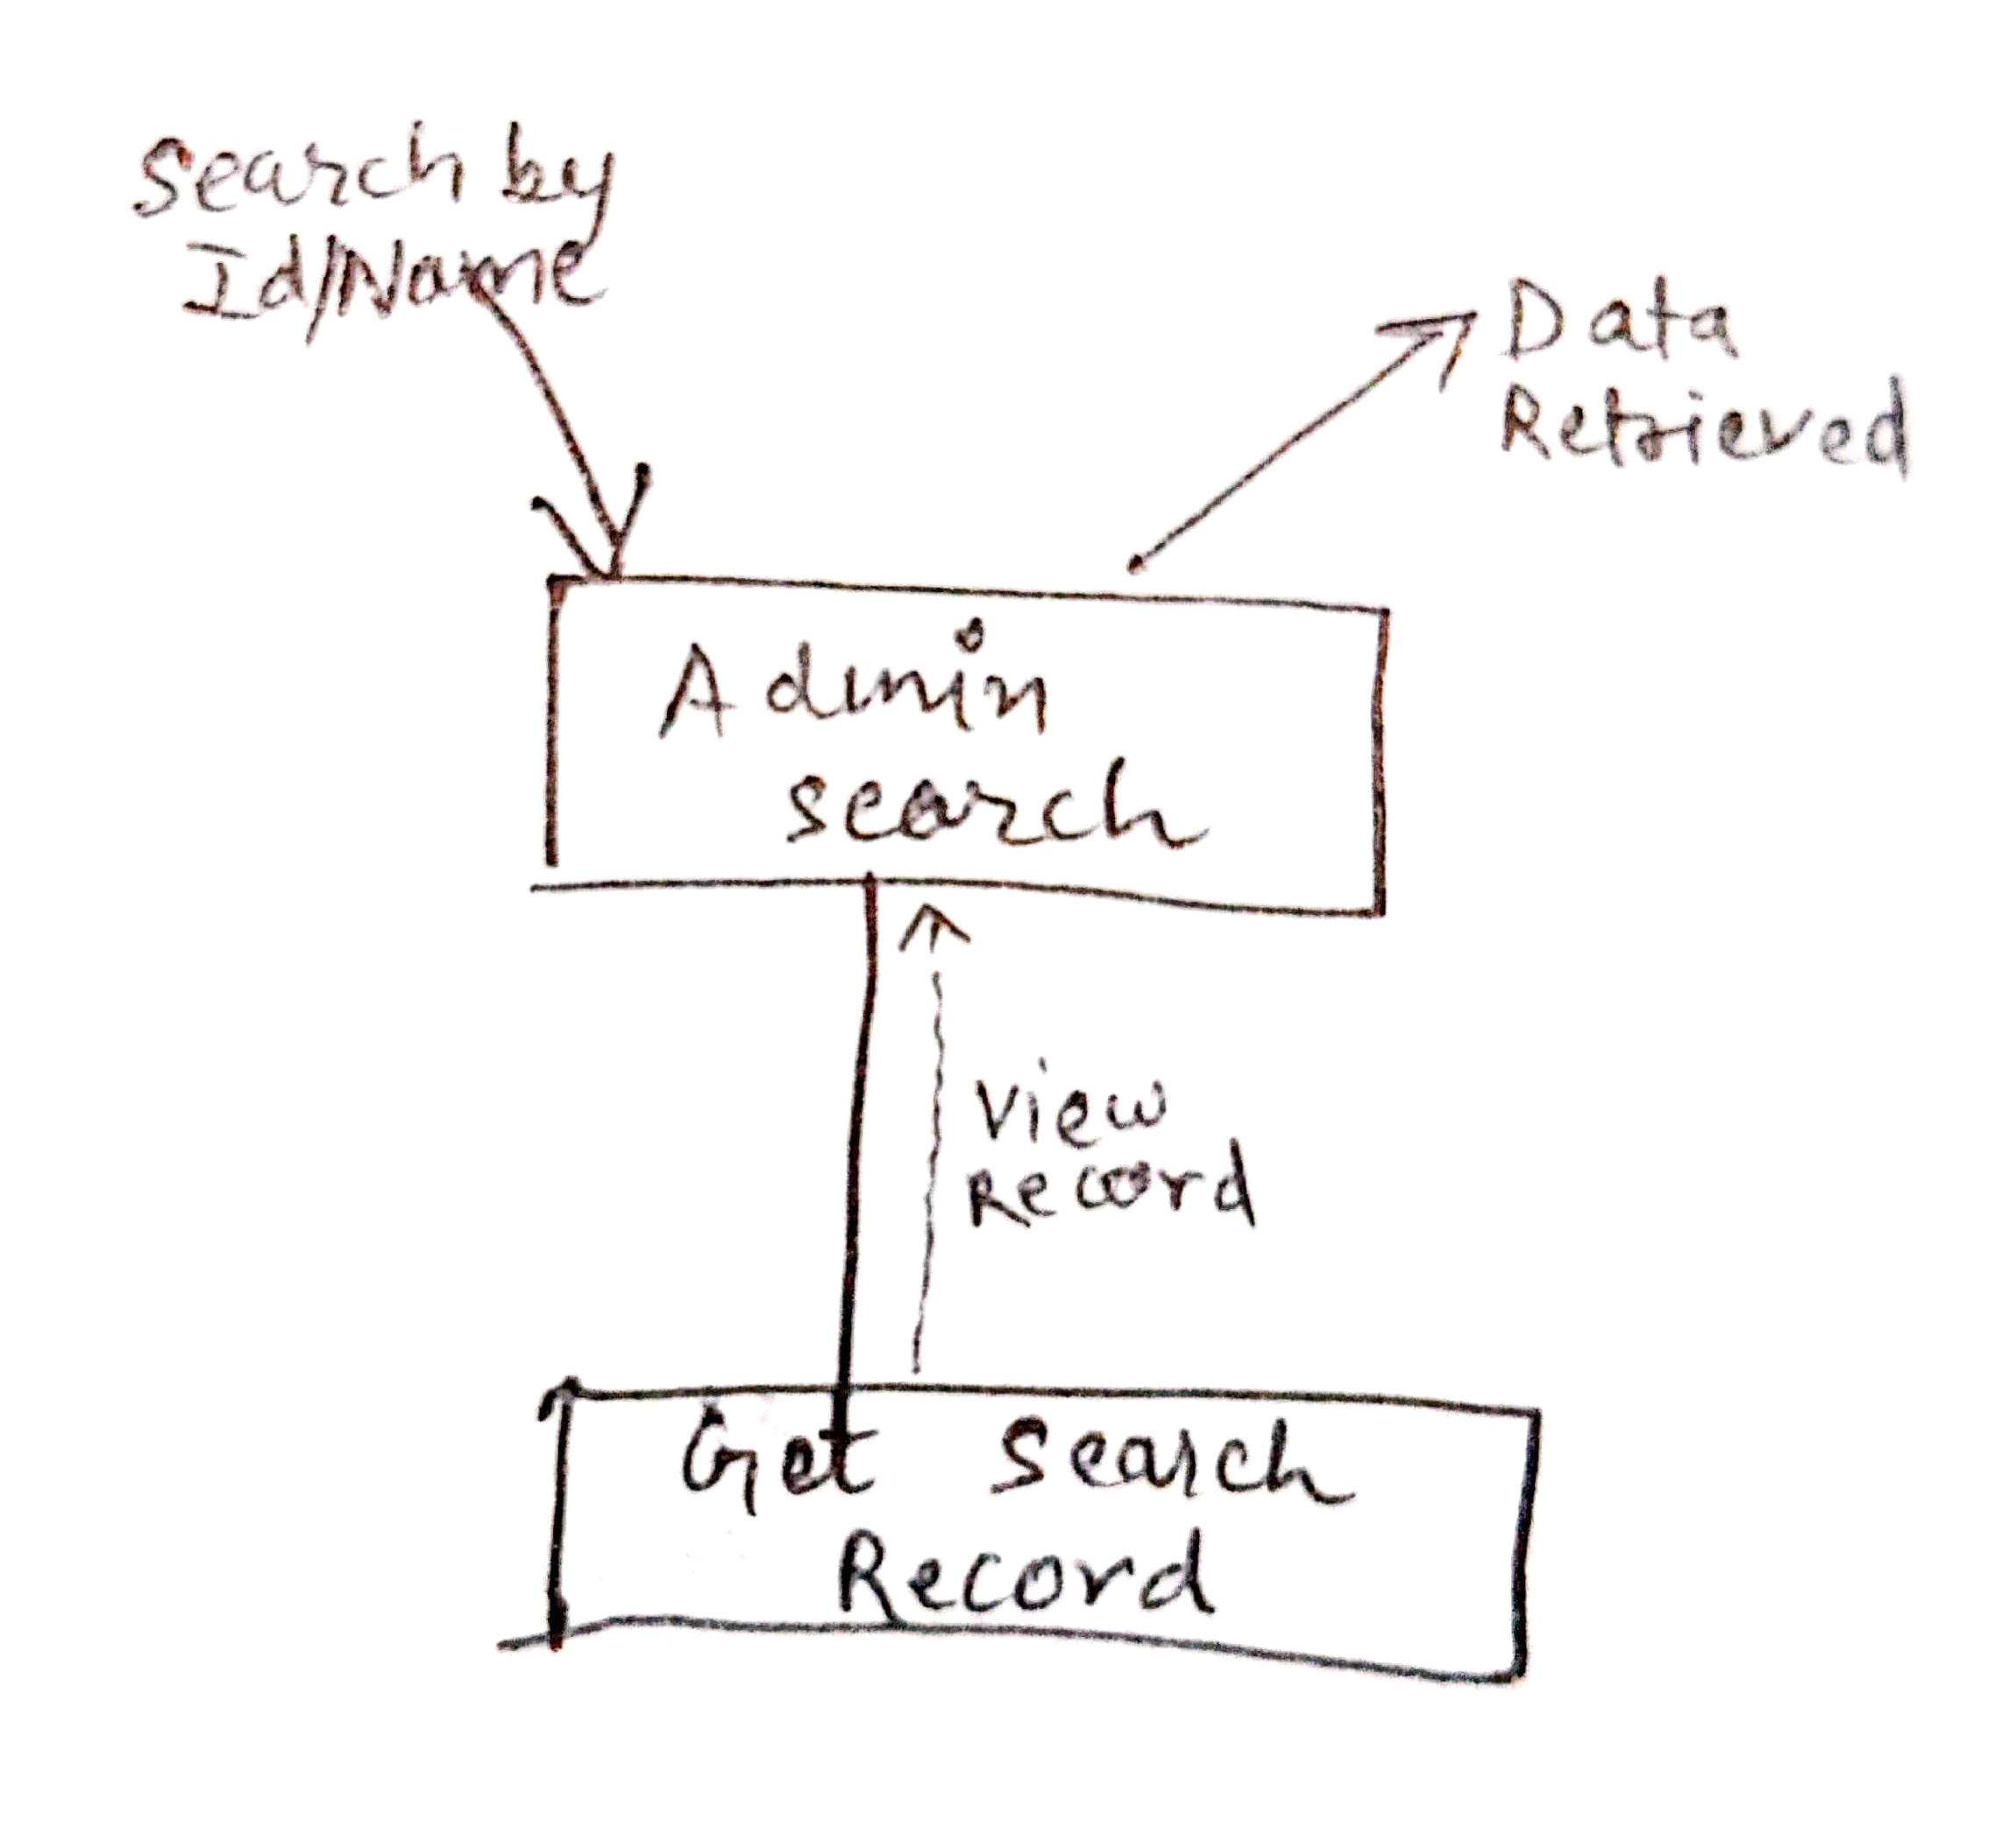

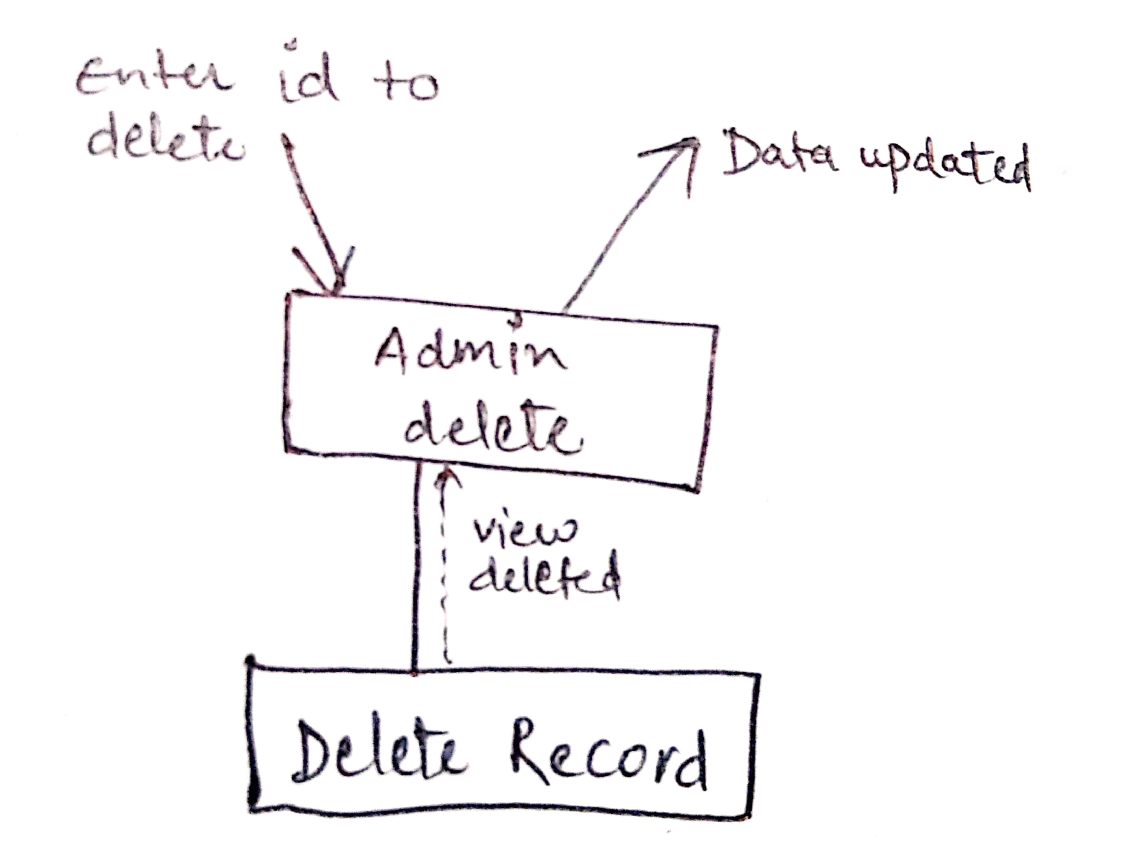

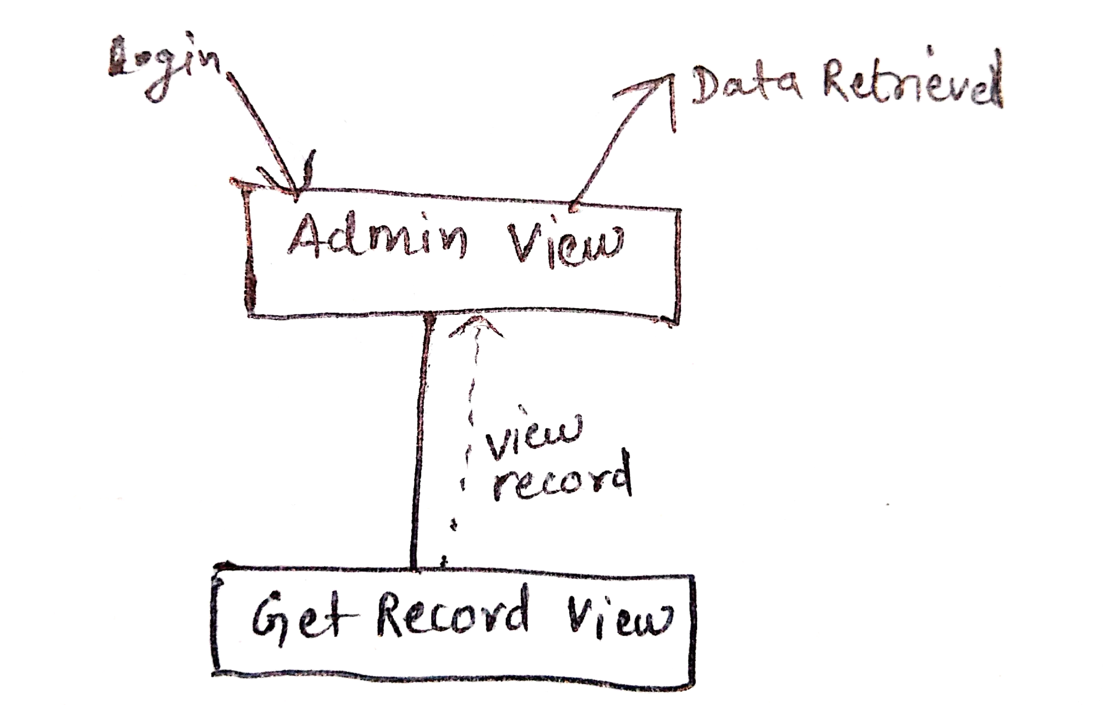

**Factor Efferent :**

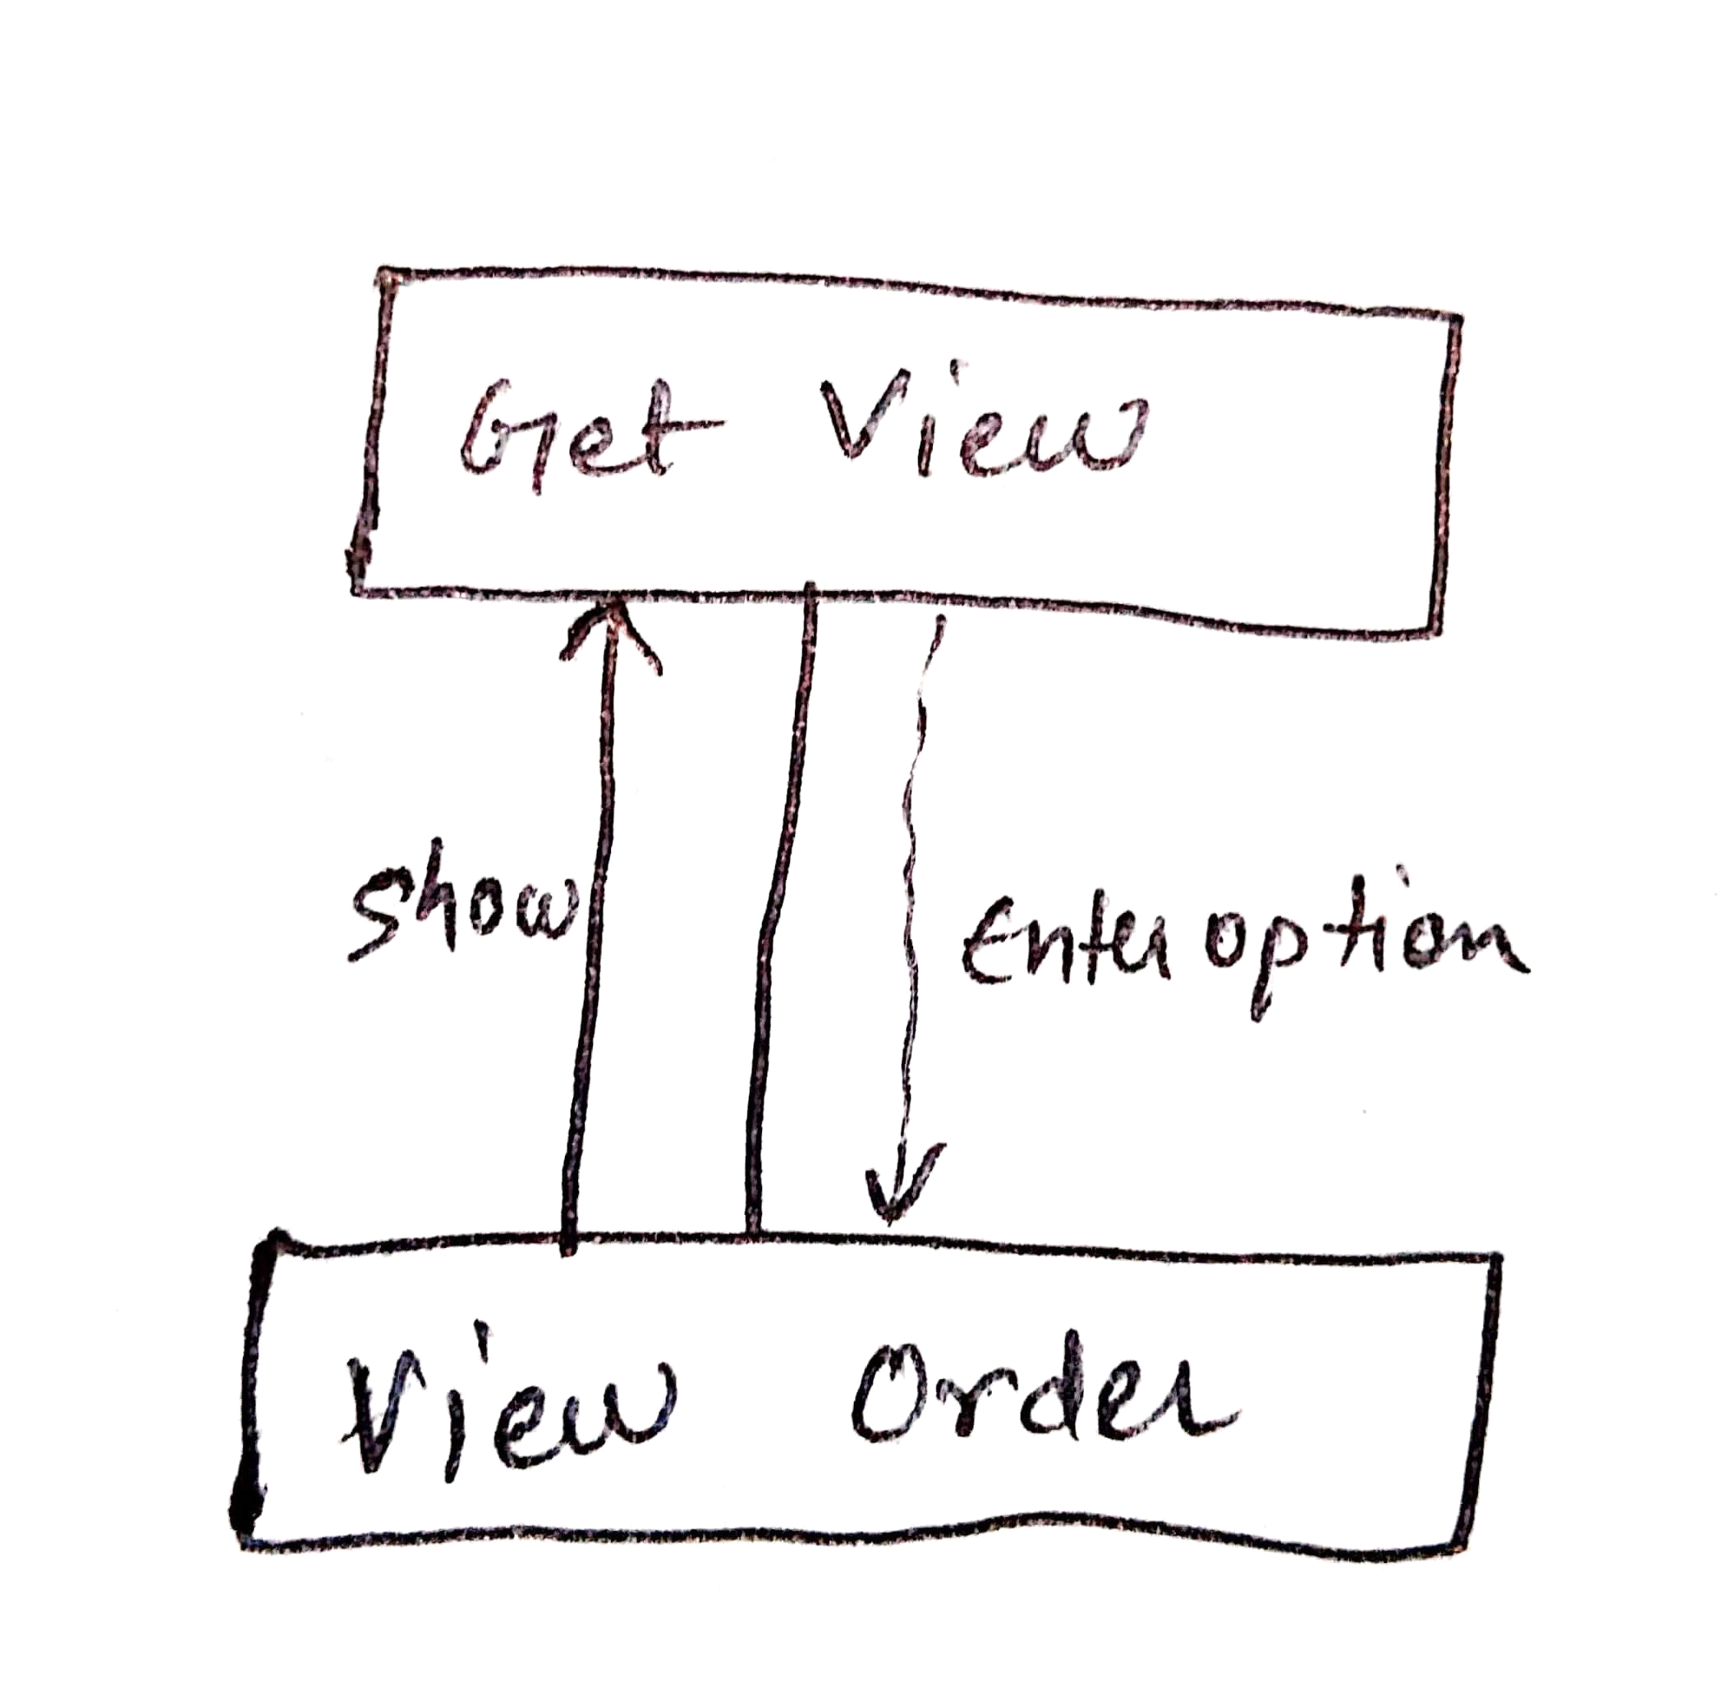

**STUDENT**

**Factor Afferent :**

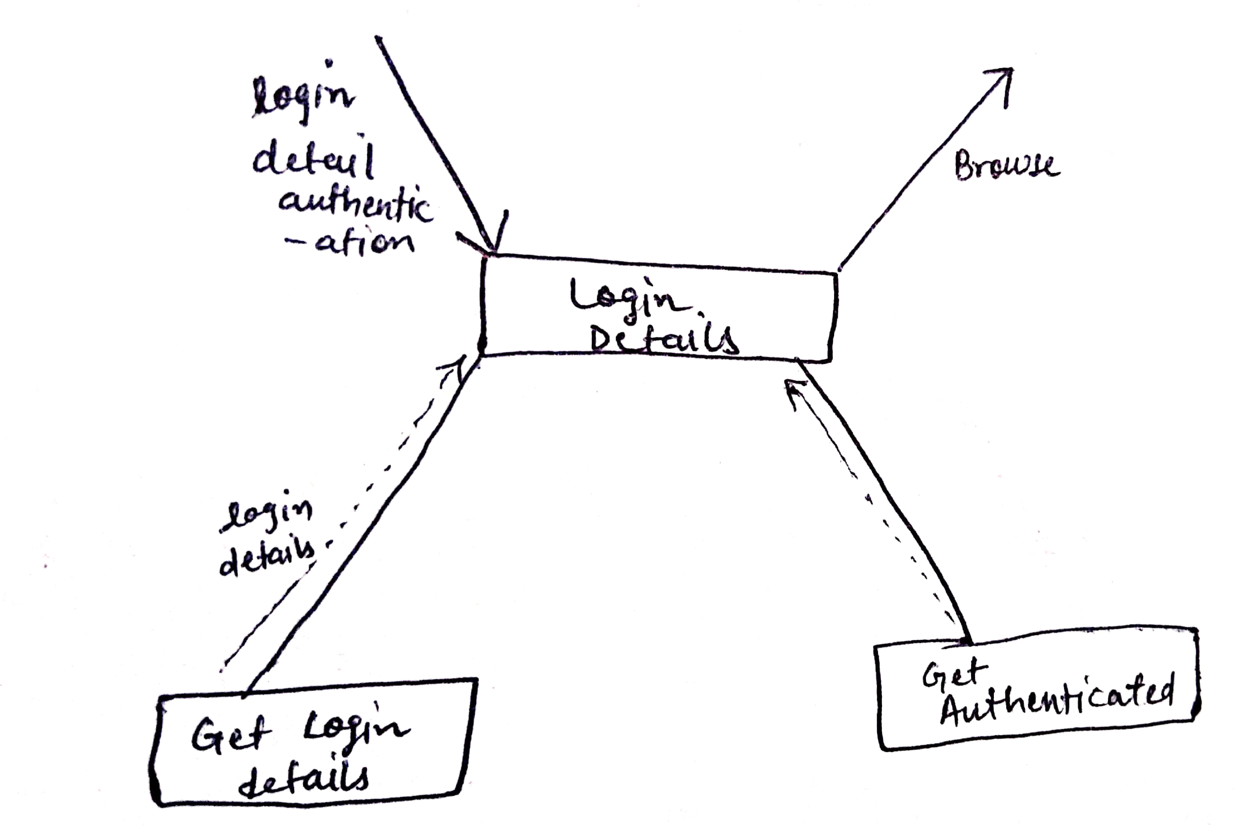

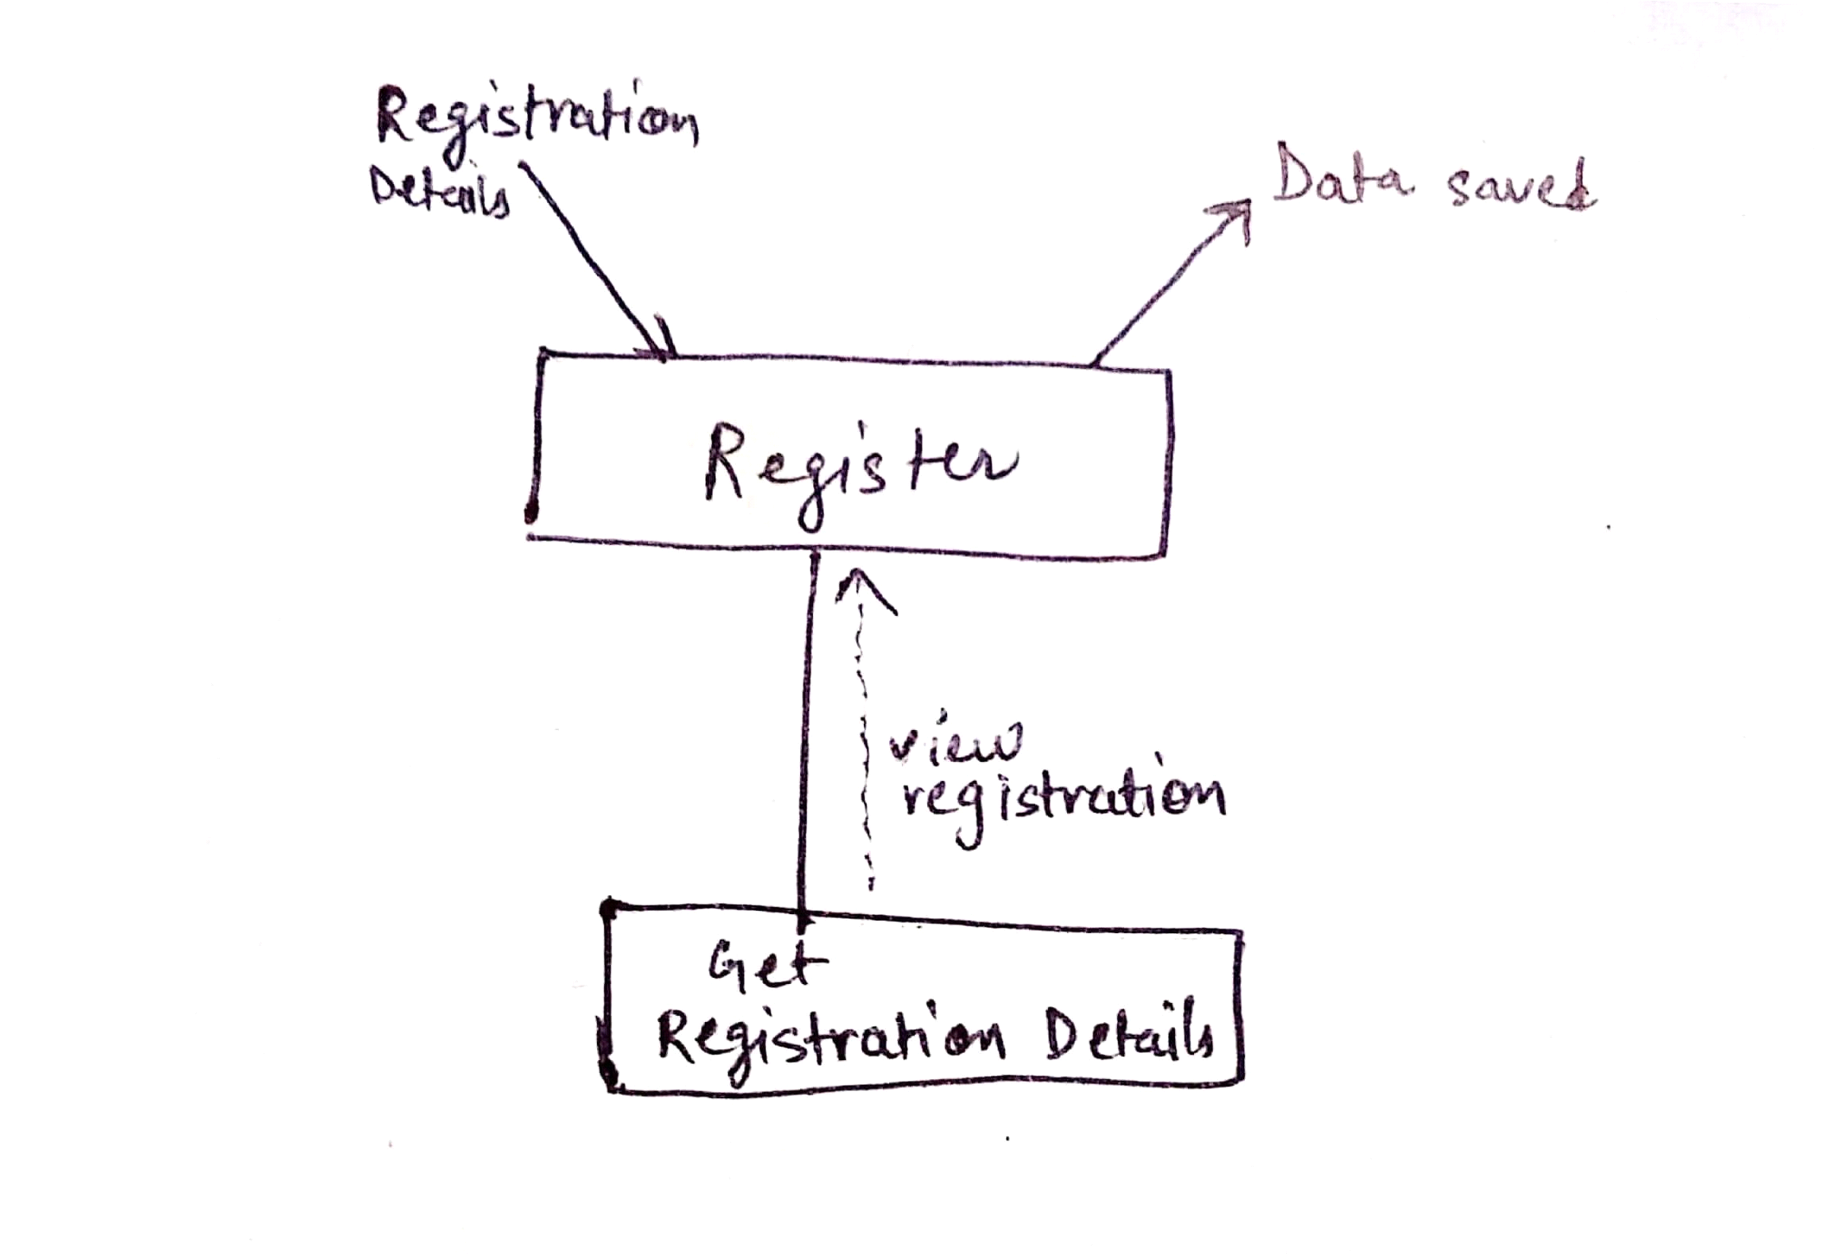

**Factor Efferent :**

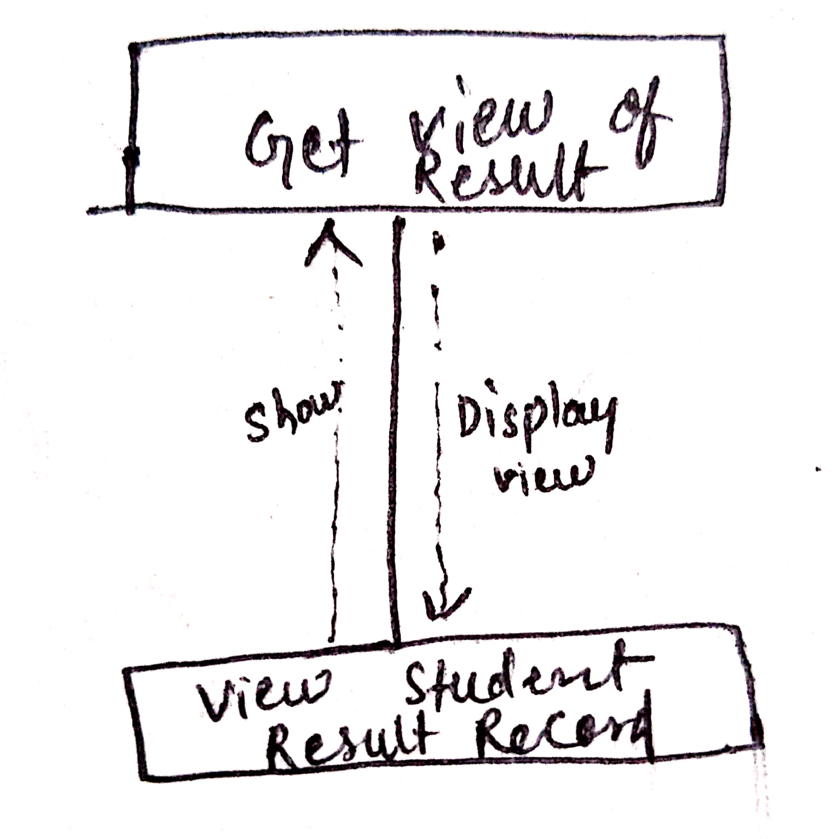

**SUPERVISOR**

**Factor Afferent :**





**Factor Efferent :**

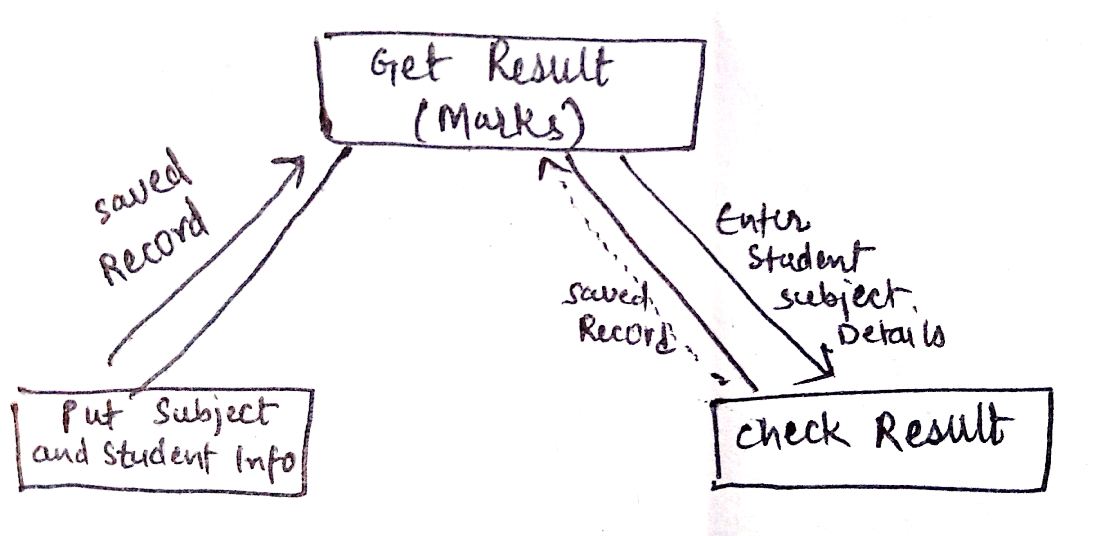

**Central Transformation :**

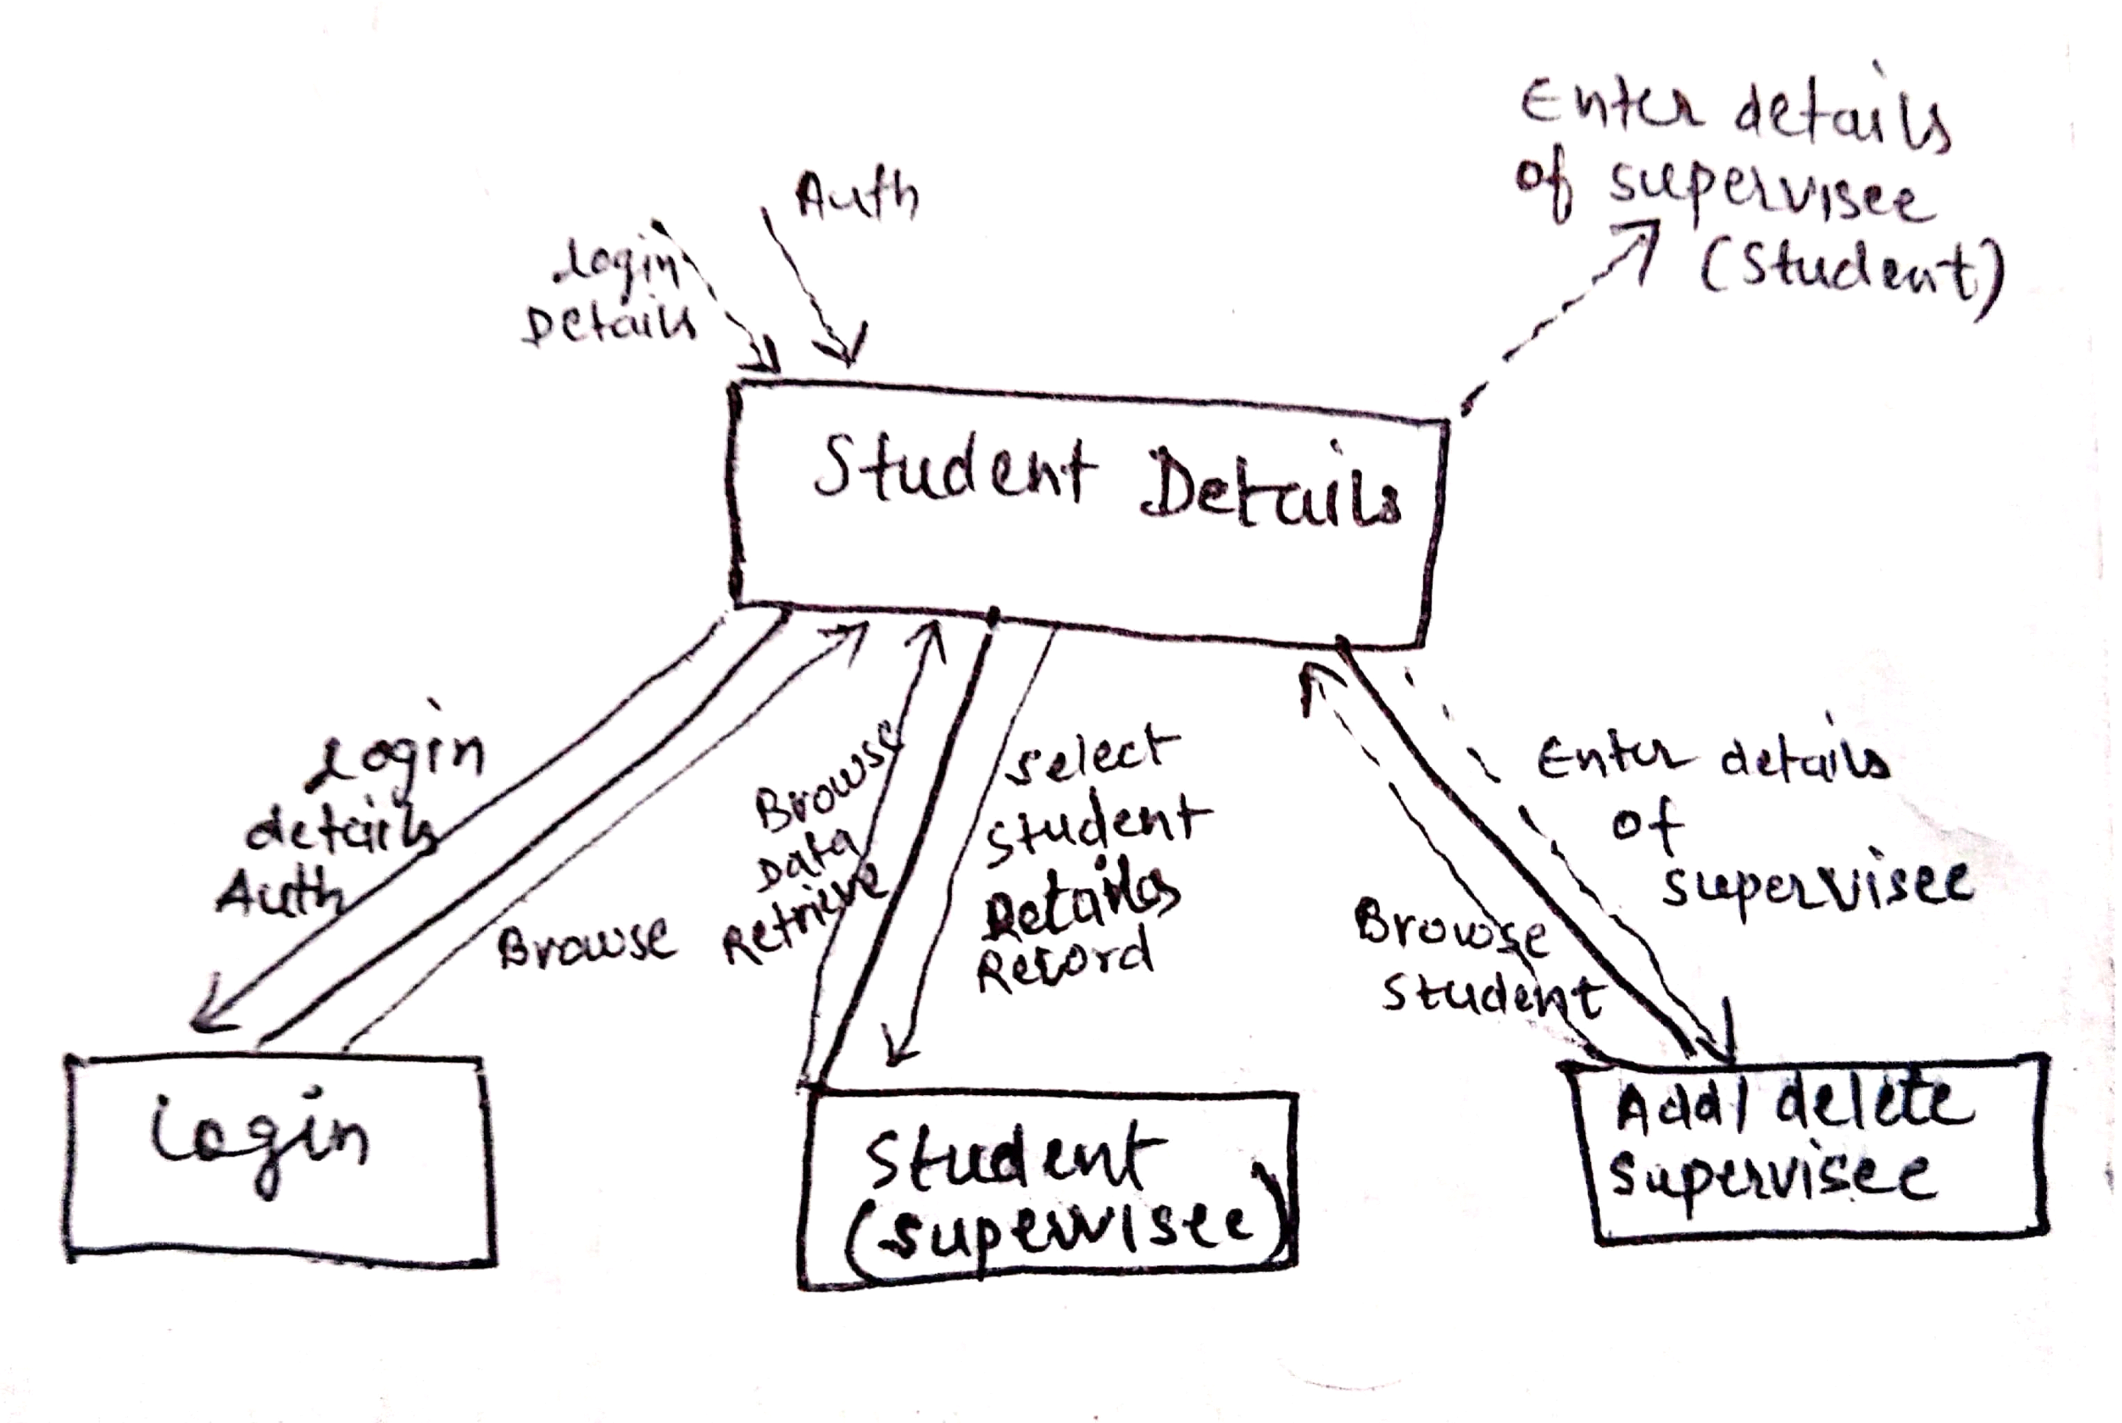

**First Cut :**

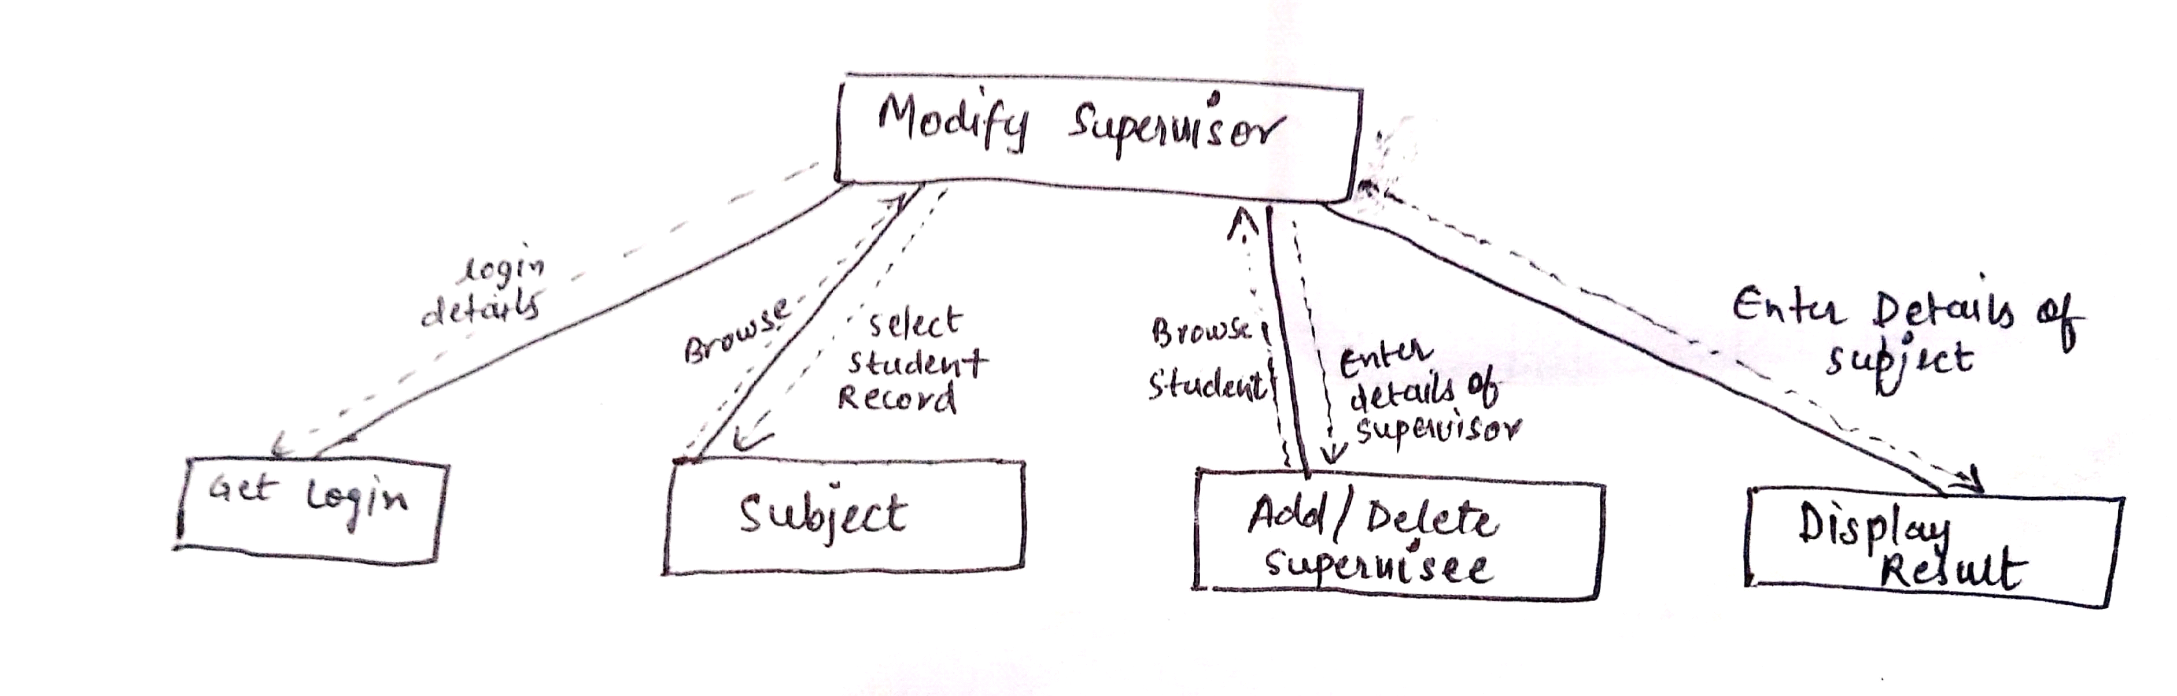

**For TEACHER :**

**Factor Afferent :**





**Factor Efferent :**



**Central Transformation :**

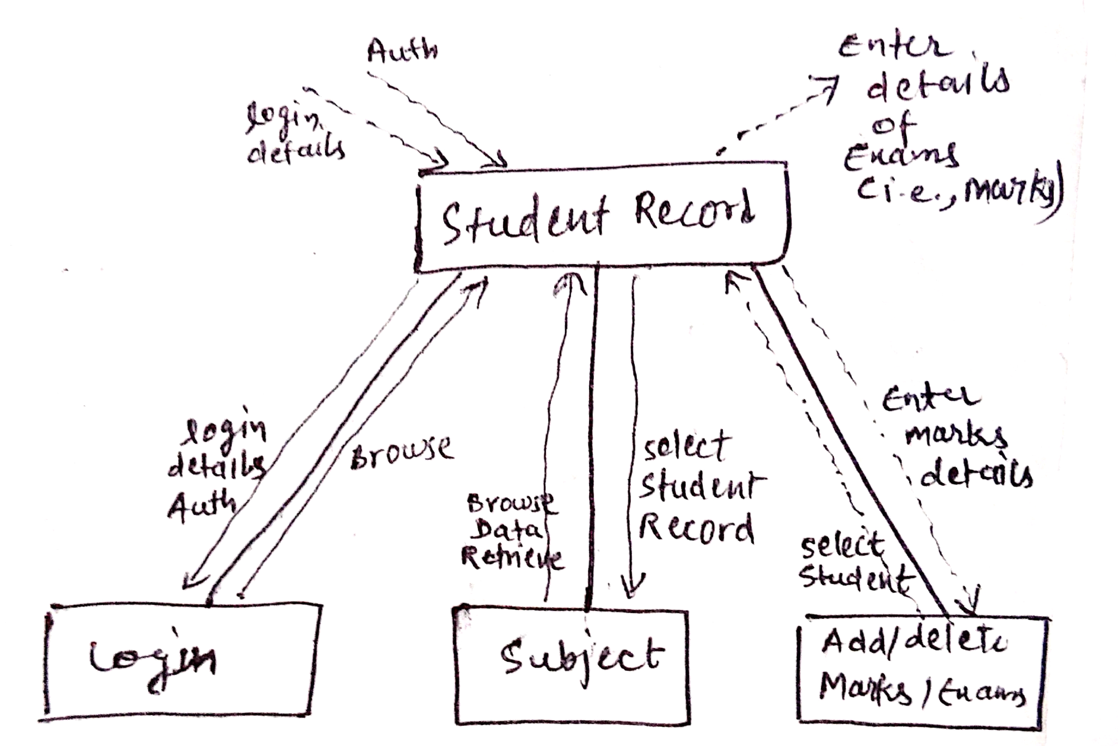

**First Cut :**

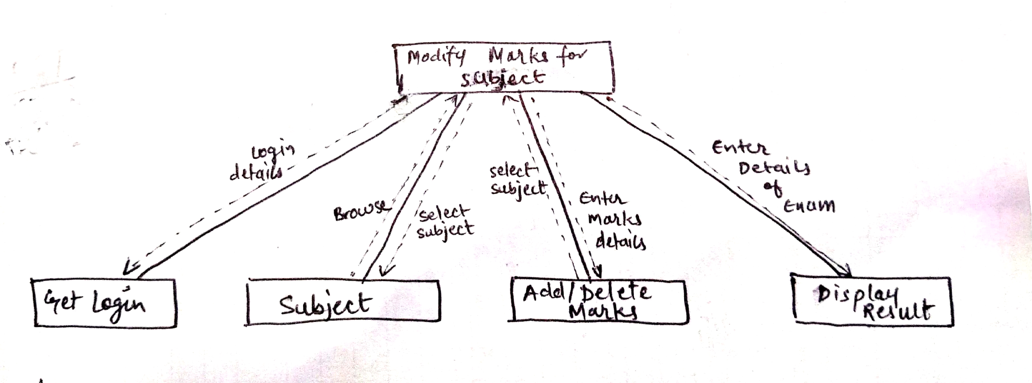

**COHESION AND COUPLING**

**Coupling:** Coupling is the measure of the degree of interdependence between the modules. A good software will have low coupling.

### **Types of Coupling:**

* + **Data Coupling:** If the dependency between the modules is based on the fact that they communicate by passing only data, then the modules are said to be data coupled. In data coupling, the components are independent to each other and communicating through data. Module communications don’t contain tramp data. Example-customer billing system.
  + **Stamp Coupling** In stamp coupling, the complete data structure is passed from one module to another module. Therefore, it involves tramp data. It may be necessary due to efficiency factors- this choice made by the insightful designer, not a lazy programmer.
  + **Control Coupling:** If the modules communicate by passing control information, then they are said to be control coupled. It can be bad if parameters indicate completely different behavior and good if parameters allow factoring and reuse of functionality. Example- sort function that takes comparison function as an argument.
  + **External Coupling:** In external coupling, the modules depend on other modules, external to the software being developed or to a particular type of hardware. Ex- protocol, external file, device format, etc.
  + **Common Coupling:** The modules have shared data such as global data structures.The changes in global data mean tracing back to all modules which access that data to evaluate the effect of the change. So it has got disadvantages like difficulty in reusing modules, reduced ability to control data accesses and reduced maintainability.
  + **Content Coupling:** In a content coupling, one module can modify the data of another module or control flow is passed from one module to the other module. This is the worst form of coupling and should be avoided.

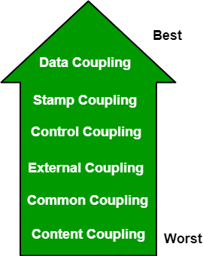

**Cohesion:** Cohesion is a measure of the degree to which the elements of the module are functionally related. It is the degree to which all elements directed towards performing a single task are contained in the component. Basically, cohesion is the internal glue that keeps the module together. A good software design will have high cohesion.

### **Types of Cohesion:**

* + **Functional Cohesion:** Every essential element for a single computation is contained in the component. A functional cohesion performs the task and functions. It is an ideal situation.
  + **Sequential Cohesion:** An element outputs some data that becomes the input for other element, i.e., data flow between the parts. It occurs naturally in functional programming languages.
  + **Communicational Cohesion:** Two elements operate on the same input data or contribute towards the same output data. Example- update record int the database and send it to the printer.
  + **Procedural Cohesion:** Elements of procedural cohesion ensure the order of execution. Actions are still weakly connected and unlikely to be reusable. Ex- calculate student GPA, print student record, calculate cumulative GPA, print cumulative GPA.
  + **Temporal Cohesion:** The elements are related by their timing involved. A module connected with temporal cohesion all the tasks must be executed in the same time-span. This cohesion contains the code for initializing all the parts of the system. Lots of different activities occur, all at in it time.

**Logical Cohesion:** The elements are logically related and not functionally. Ex- A component reads inputs from tape, disk, and network. All the code for these functions is in the same component. Operations are related, but the functions are significantly different.

**Coincidental Cohesion:** The elements are not related(unrelated). The elements have no conceptual relationship other than location in source code. It is accidental and the worst form of cohesion. Ex- print next line and reverse the characters of a string in a single component.

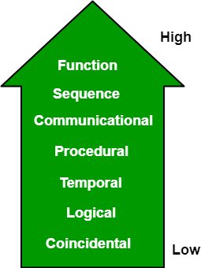

## Types of Cohesion and Coupling to be achieved

1. **Data Coupling :** The aim is to enforce data coupling where no extraneous data is to be passed as a parameter , the arguments should be homogeneous and every function should have one entry point and only one exit point. This is achieved in central transform modules
2. **Functional Cohesion :** The aim is to ensure functional cohesion where every module is responsible for performing a specific task. Every module takes an individual action and calls another function if it requires to perform any other task.

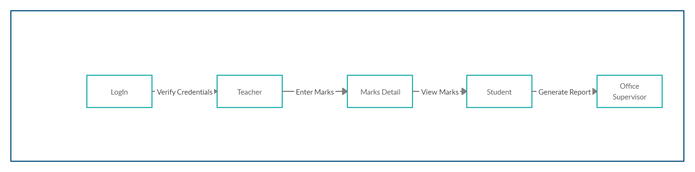

**TESTING**

Testing is a process of executing a program with the aim of finding error. To make our software perform well it should be error free.If testing is done successfully it will remove all the errors from the software.

### **Principles of Testing:-**

1. All the test should meet the customer requirements
2. To make our software testing should be performed by third party
3. Exhaustive testing is not possible.As we need the optimal amount of testing based on the risk assessment of the application.
4. All the test to be conducted should be planned before implementing it
5. It follows pareto rule(80/20 rule) which states that 80% of errors comes from 20% of program components.
6. Start testing with small parts and extend it to large part

## UNIT TESTING

It focuses on smallest unit of software design. In this we test an individual unit or group of inter related units.It is often done by programmer by using sample input and observing its corresponding outputs.

## INTEGRATION TESTING

The objective is to take unit tested components and build a program structure that has been dictated by design. Integration testing is testing in which a group of components are combined to produce output.

## FUNCTIONAL TESTING

FUNCTIONAL TESTING is a type of software testing whereby the system is tested against the functional requirements/specifications.

Functions (or features) are tested by feeding them input and examining the output. Functional testing ensures that the requirements are properly satisfied by the application. This type of testing is not concerned with how processing occurs, but rather, with the results of processing. It simulates actual system usage but does not make any system structure assumptions.

During functional testing, Black Box Testing technique is used in which the internal logic of the system being tested is not known to the tester.